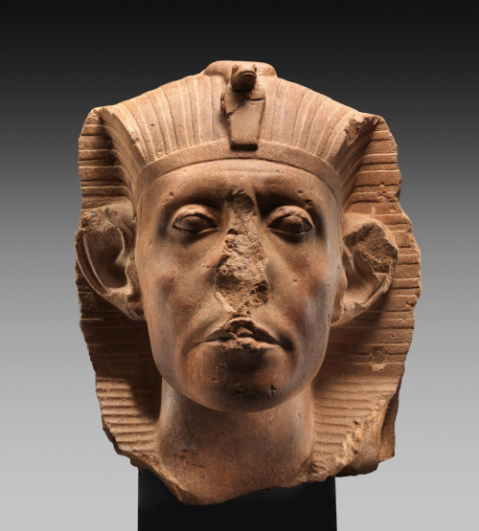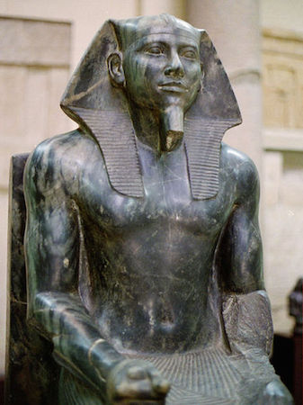
Identify each sculpture with its name and period.
The title of the first art is “Head of Sen-useret III.”It is a sculpture made of yellow quartzite from the period 1874 – 1855 B.C.E. The title of the second is “Khafre Enthroned.” The sculpture is composed of diorite from the era 2520-2494 B.C.E.
Describe the sculpture formally
The sculpture is a head portrait that portrays Sesostris III with deeply set eyes, having pouches under them. The curvature of the mouth curves with shallow lines at the edges, the brow-bridge overhangs. The portrait shows high cheek bones for the pharaoh, as though almost protruding through the flesh. The ears are large and flaring, and the depiction of the chin is as a strong and rounded. The face is unlined except for the horizontal furrow across the brow. He wears he royal nemes with a uraeus upfront.
Khafre Enthroned is a funerary statue depicting is ancient Egyptian Pharaoh of the same name. The pharaoh is sited, and his face is idealized with an athletic physique in the prime of his life. The use of diorite in the art creates a sense of permanence, which portrays an eternal stillness for the eternal afterlife. The Pharaohs head has a symbol of the wings of the eternal-god Horus as protection. As a god-king, the sculpture has no flaws in skin or proportions. Khafre dons the royal linen nemes headdress with the uraeus cobra of kingship on the front.
Compare and contrast: How are they similar? How are they different? How are thy depictions of their time period?
The sculptures portray both pharaohs in the prime of their actual age at the time, and both head have the pharaoh’s nemes with uraeus in front. The two are different in that the first is just an art piece of only the head of the pharaoh, while the other is a full-sized sculptur, almost to scale. There is also a difference in how each sculptur symbolizes eternity; the Head of Sen-useret III uses the color yellow which was a symbol for eternity such as Nebu and the sun. The Khafre Enthroned sculpture uses diorite to represent the same. The materials used in sculpting are testament to the time frame of the art.

